Heart Risk Predictions Report
By Jonathaniel Alipes
Using our Heart Risk dataset, we will be determining key factors in what causes heart risks. We will thoroughly analyze the dataset using a process called exploratory data analysis to determine key characteristics or features and will be using the decided features to create and evaluate a model that can best predict heart risk.

Exploratory Data Analysis

Initial Analysis

Univariate Analysis
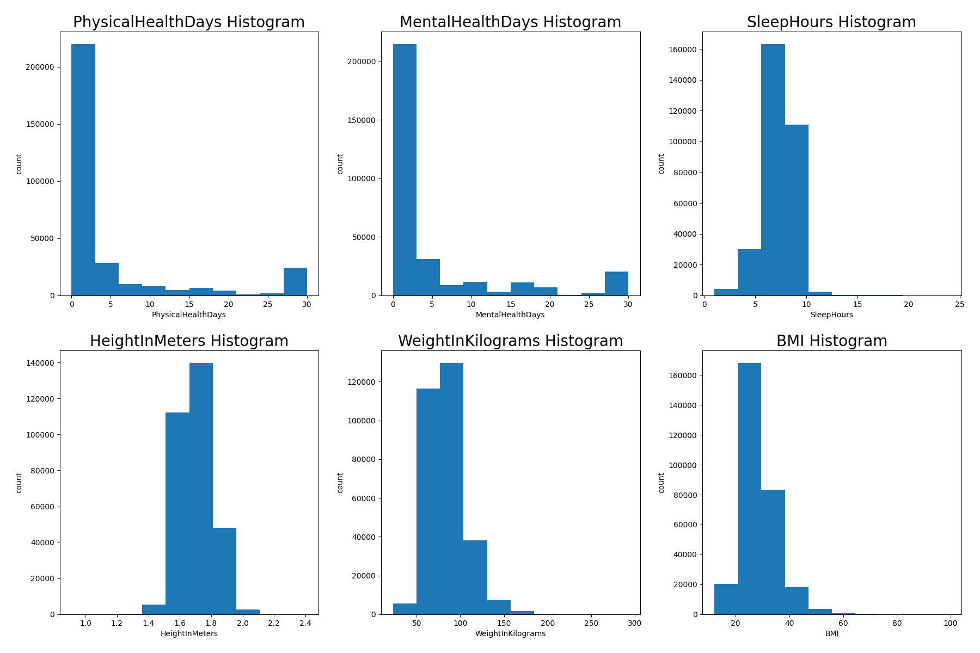
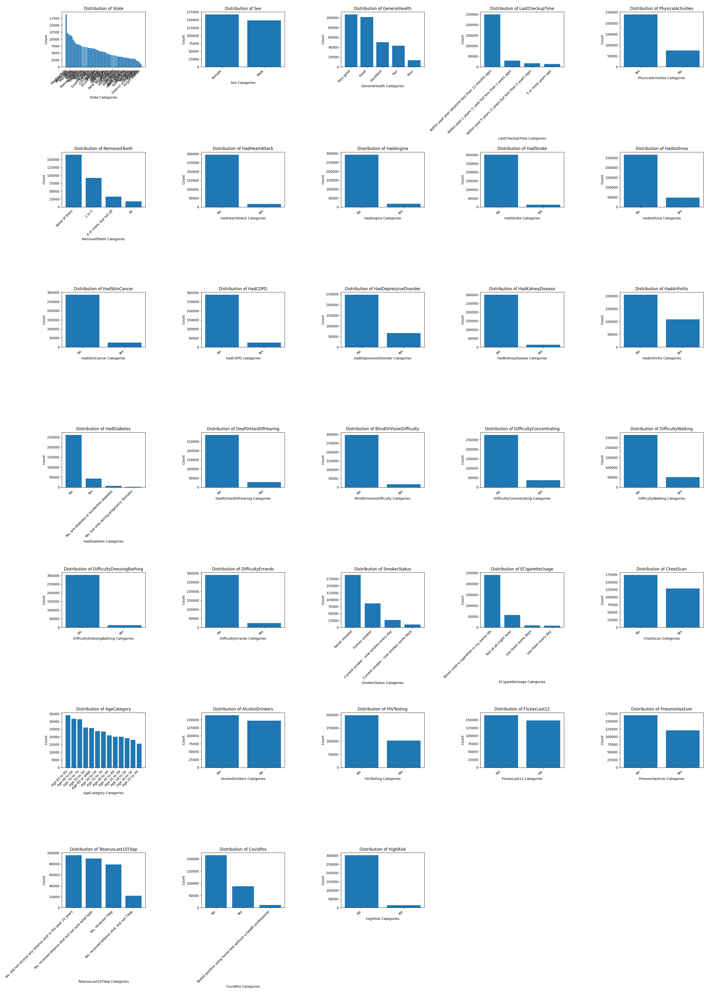

Multivariate Analysis

Model Evaluations

Model Comparison

Best Model

